**CLOUD SERVERLESS COMPUTING**

CREATING A PIZZA ORDER CHATBOT USING AMAZON LEX, AWS LAMBDA, IAM, KOMMUNICATE

STEP 1 : LOG IN TO AWS MANAGEMENT CONSOLE

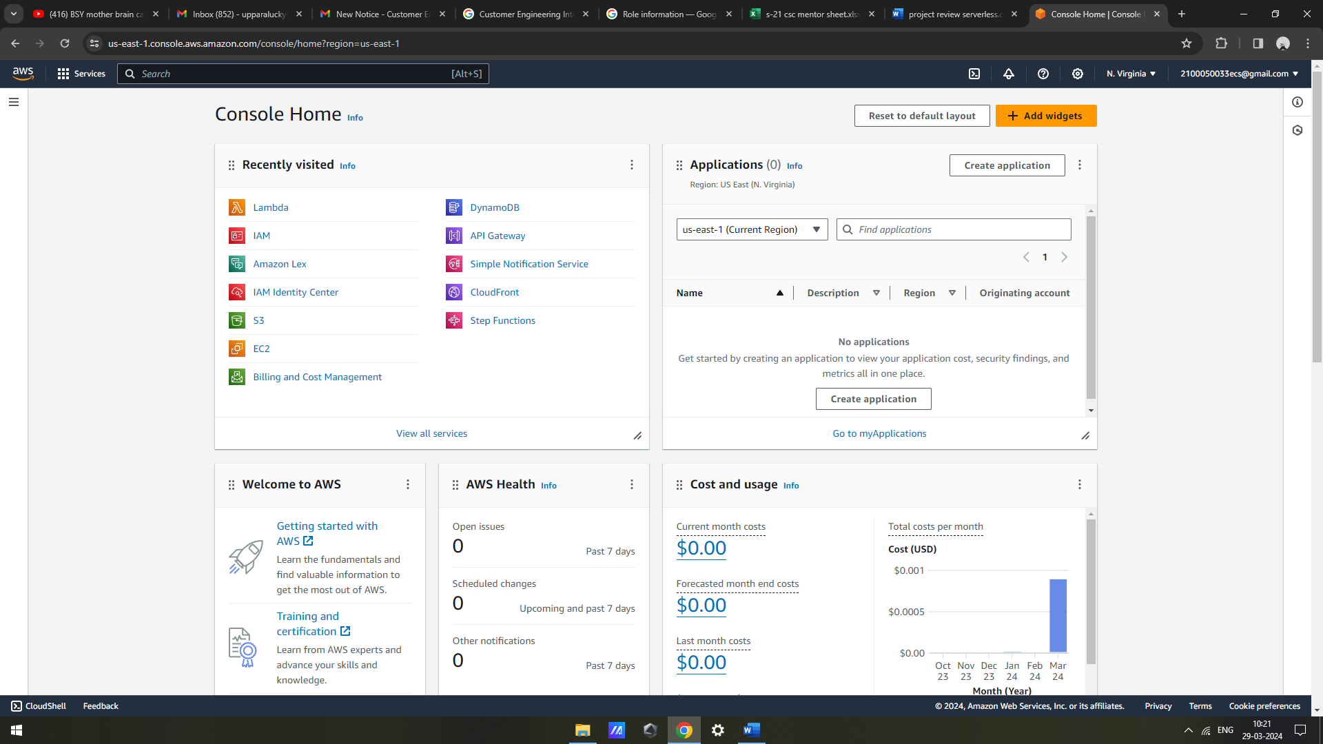

STEP 2: GO TO SERVICES TAB AND SEARCH FOR AMAZON LEX AND CLICK ON IT

STEP 3 : CREATE A CHATBOT WITH NAME BURGER BUDDY AND CREATE INTENTS

STEP 4 : CREATE THREE NEW SLOT TYPES

STEP 5 : CREATE A SLOT BURGER SIZE

STEP 6 : CREATE A SLOT BURGER TYPES

STEP 7 : CREATE A SLOT BURGER FRANCHISE

STEP 8 : CREATE AN INTENT ORDER BURGER

STEP 9 : ADD SLOTS IN THE INTENT

STEP 10 : FILL THE INTENT DETAILS

STEP 11 : BUILD THE CREATED BOT

STEP 12 : TEST THE BOT

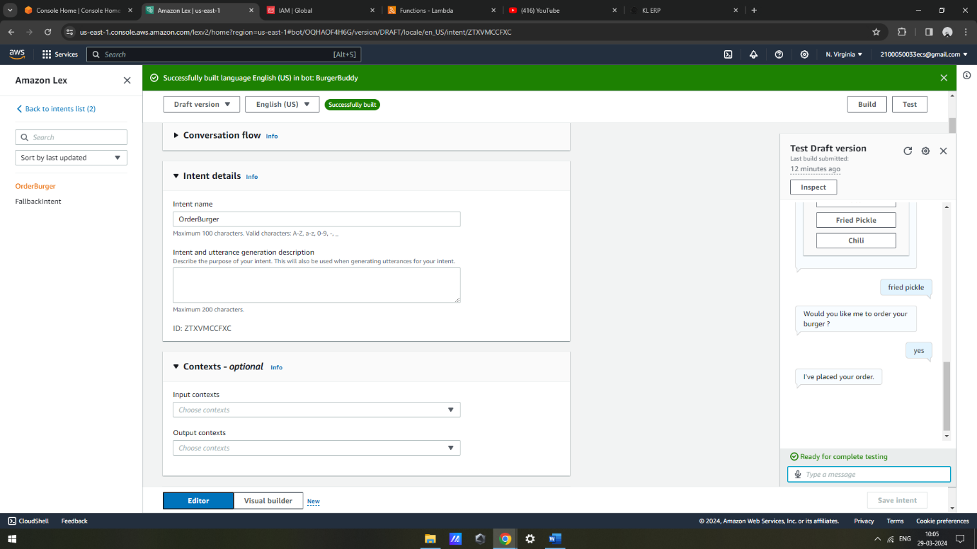

STEP 13 : CREATE AN IAM ROLE

STEP 14 : CREATE A LAMBDA FUNCTION

STEP 15 : DEPLOY THE LAMBDA FUNCTION

STEP 16 : LAMBDA TRIGGER IN LEX

STEP 17 : CREATE A HTML PAGE

STEP 18 : INTEGRATE THE HTML PAGE WITH THE AWS CHAT BOT

THE FINAL OUTPUT :

